
Bunbury Senior High School
Chemistry Unit 1 & 2

Assignment #1:
Validation Test

NAME: ______________________________________

Reading time: 5 minutes
Working time: 55 minutes

Section | Mark
Written assignment | / 24
Validation test  (= Test score x2) | / 76
Total | / 100

- (10 marks)

- Draw a labelled diagram of an atomic absorption spectrophotometer. (2 marks)

- Explain why elements emit and absorb characteristic wavelengths of light. Include a diagram as part of your answer. (3 marks)

- Explain how an atomic absorption spectrophotometer is able to measure the concentration of trace metals in a sample. Refer to the roles of different parts of the machine in your answer. (5 marks)

- (8 marks)

A chemist wished to analyse the amount of zinc in dietary supplement tablets. They prepared 4 tablet samples for analysis by dissolving the tablets individually in 10% nitric acid. Each tablet solution was made up to a final volume of 100 mL. Five standard solutions of zinc were also prepared. The absorbances of the standard and sample solutions were determined by atomic absorption spectroscopy of 213.9 nm, and the results are shown in the table blow.

Standard zinc solutions (mg L⁻¹) | Absorbance
0.00 | 0.000
1.00 | 0.170
2.00 | 0.330
3.00 | 0.503
4.00 | 0.680
Tablet samples: mean absorbance | 0.280

- Plot a calibration curve for the standard zinc solutions on the grid below. (5 marks)



- Using the mean absorbance for the tablet samples, calculate the mean amount of zinc per tablet in mg. (3 marks)

- (4 marks)

Gas chromatograms are instruments which are able to separate compounds from a mixture. A diagram of a gas chromatogram is shown below:

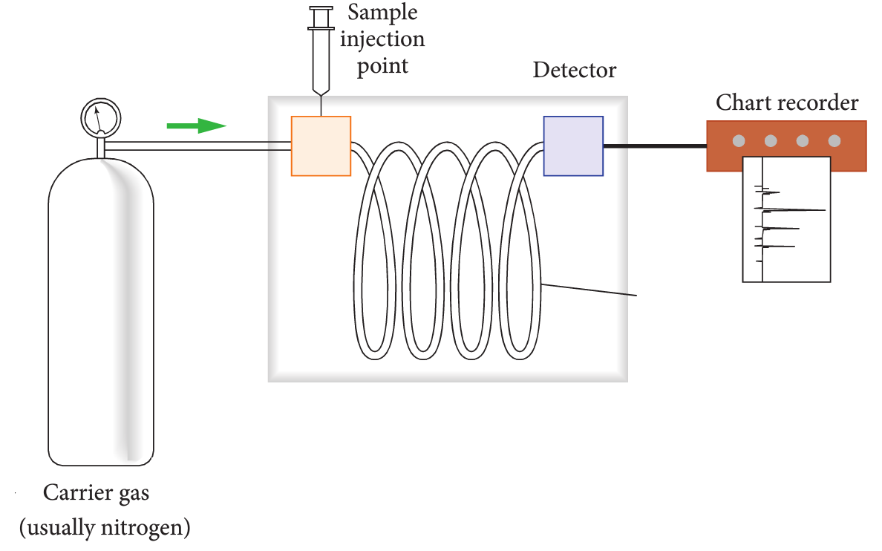
X
Y

- Name the part labelled X on the diagram. (1 mark)

- Name the part labelled Y on the diagram. (1 mark)

- Why do substances become separated when they move through the part labelled X. (2 marks)

- (4 marks)

An athlete provided a urine sample to be tested for steroids. The sample and the steroid standards were treated and then analysed by gas chromatography with mass spectrometric detection.

Below are the chromatograms of a standard mixture containing four different steroids, and the sample from the athlete.

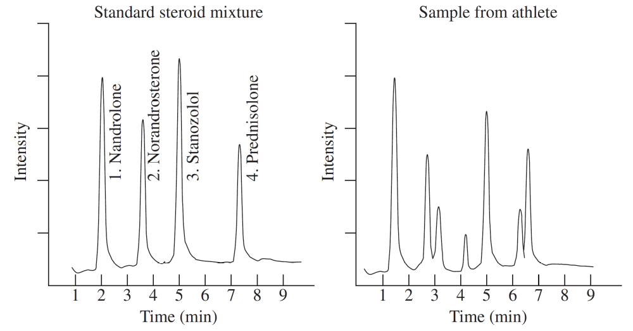

- Which steroid has the athlete taken? Justify your answer. (2 marks)

- It is possible for two different compounds to have the same retention time during gas chromatography, thus gas chromatographs would not conclusively prove in court whether or not the athlete has taken a type of steroid. How could a forensic scientist use mass spectrometry to confirm whether or not the steroid is present in the urine sample? (2 marks)

- (2 marks)

An unknown sample was collected and was analysed by mass spectrometry. The mass spectrum of the substance is shown below:
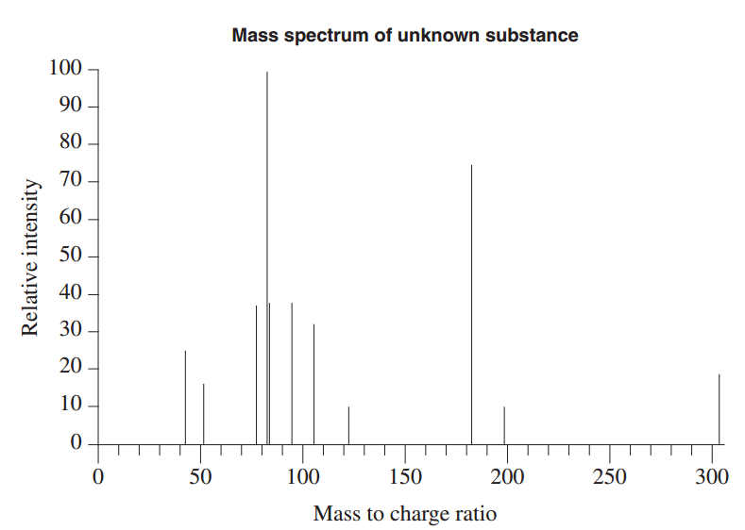

This table shows the mass to charge ratio of a selection of fragments in the mass spectrum for three compounds of interest in forensic investigations.

Compound name | Significant fragments  (mass to charge ratio)
Caffiene | 67 109 194
Cocaine | 82 94 182
Paracetemol | 43 109 151

What is the identity of the unknown substance? Justify your answer. (2 marks)

- (5 marks)

A pure, gaseous sample of element Z is introduced into a mass spectrometer, and the spectrum below is generated:
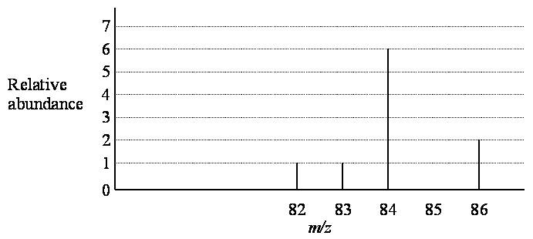

- What do the peaks in this spectrum represent? (2 marks)

- Calculate the average atomic mass of element Z. (2 marks)

- Using your periodic table, identify and name element Z. (1 mark)

- (5 marks)

Explain how a mass spectrometer generates spectra similar to those shown in Question 5 and Question 6. Include a diagram as part of your answer.

